Jason Rivkin

Ashley Brown

Michael Carter

Matthew Lam

James Pease

MIS 411 Database Implementation Assignment

1. **Creating Our Database Virtual Machine**

We installed our database virtual machine using the MariaDB Marketplace Image. We did so by using a standard persistent disk with 10 GB.

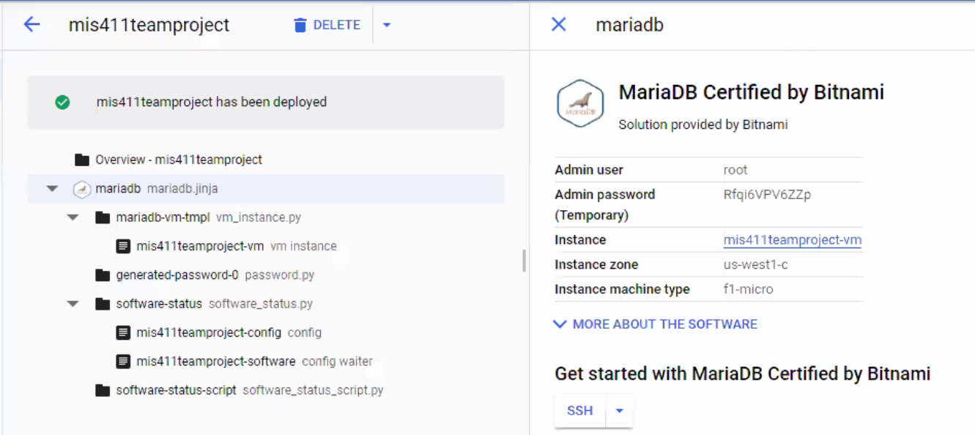

**2. Creating Our Non-Database Virtual Machine**

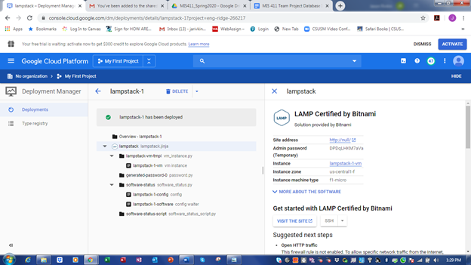

**3. Creating Our Database**

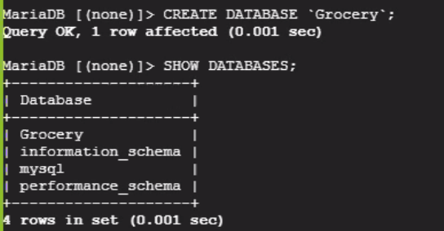

**4, 5, and 6. Creating Our Tables With Data Types and Primary and Foreign Keys**

The following screenshots below show the CREATE TABLE statements we used to create our tables in our database:

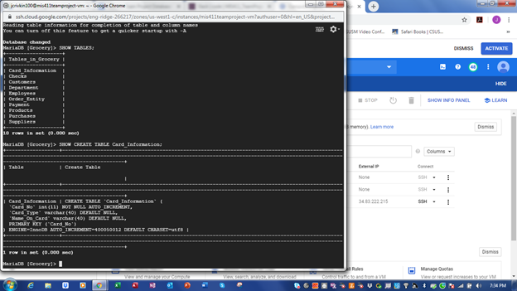

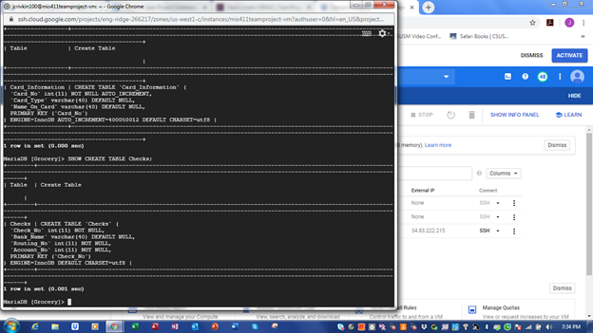

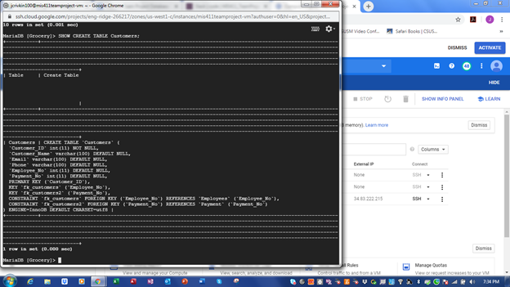

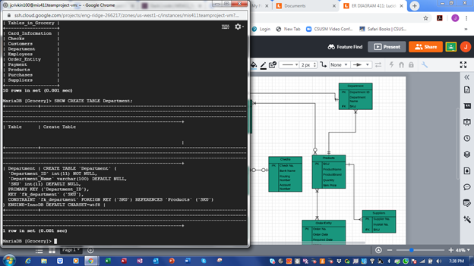

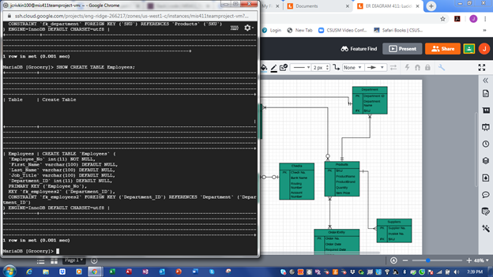

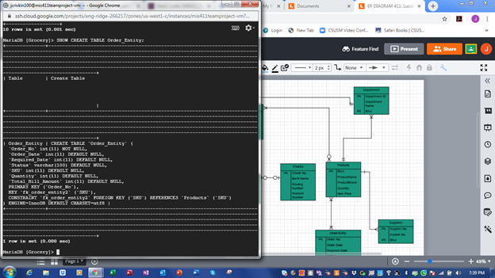

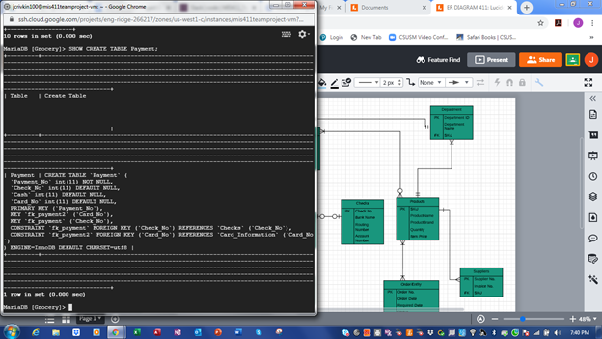

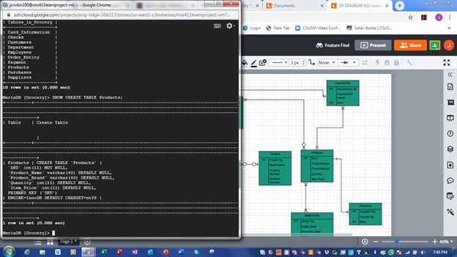

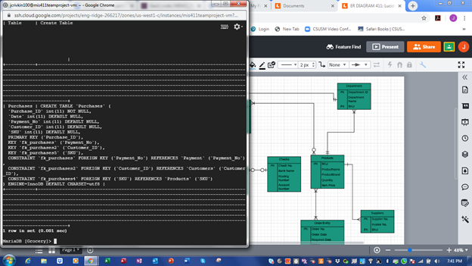

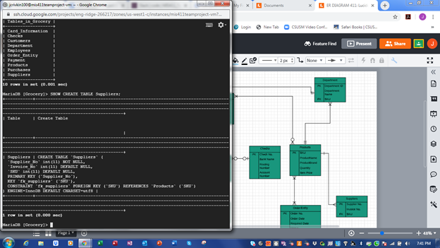

The following screenshots below show the results of our tables after having entered our CREATE TABLE statements:

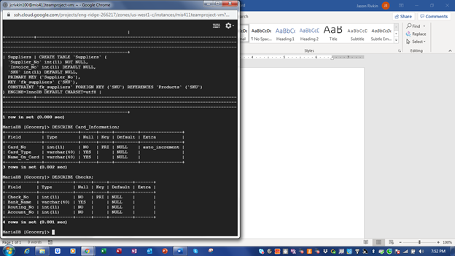

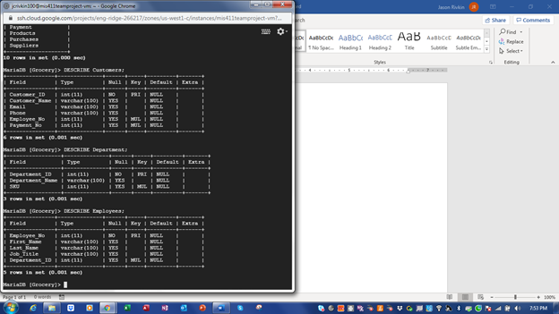

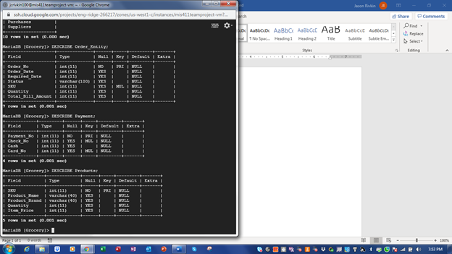

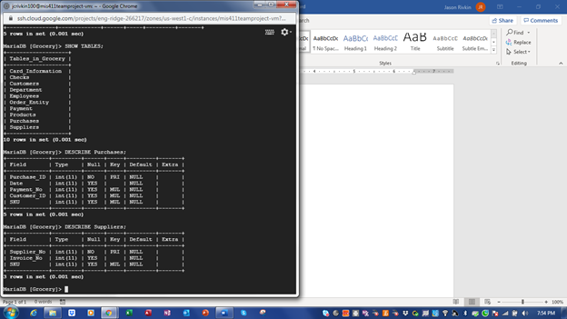

**7. Creating User Accounts and Granting Privileges**

The following screenshot below shows the details on how we created the user accounts and specified their respective grants.

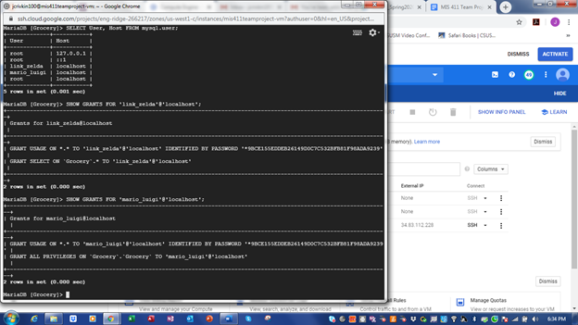

**8. Authorizing DB Access from localhost**

As shown by the screenshot above, DB access is already authorized from the local host.

**9. Authorizing DB Access from All IP Addresses**

The following screenshots show the first step of this process, which included creating the firewall rules.

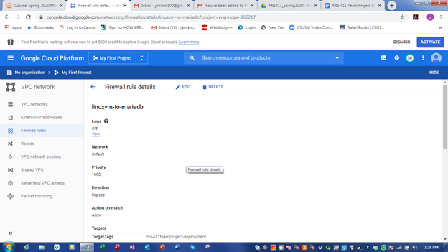

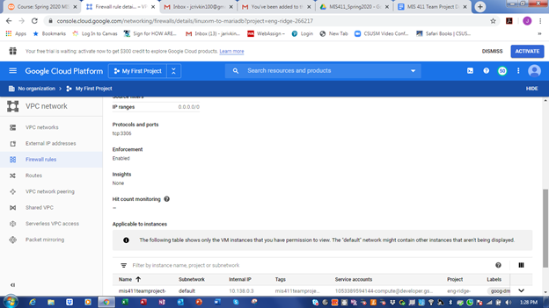

**10. Ensuring MariaDB is running on the database server. (ps -ef | grep mysqld)**

The following shows that MariaDB is running on the database server:

